Net Zero for Highway Design

**Engineers can deliver on net-zero but only if they bring communities with them**

ICE-commissioned evidence has proven that the infrastructure sector is already falling behind in the race to net zero. Passionate civil engineers who truly engage with communities can make it happen.

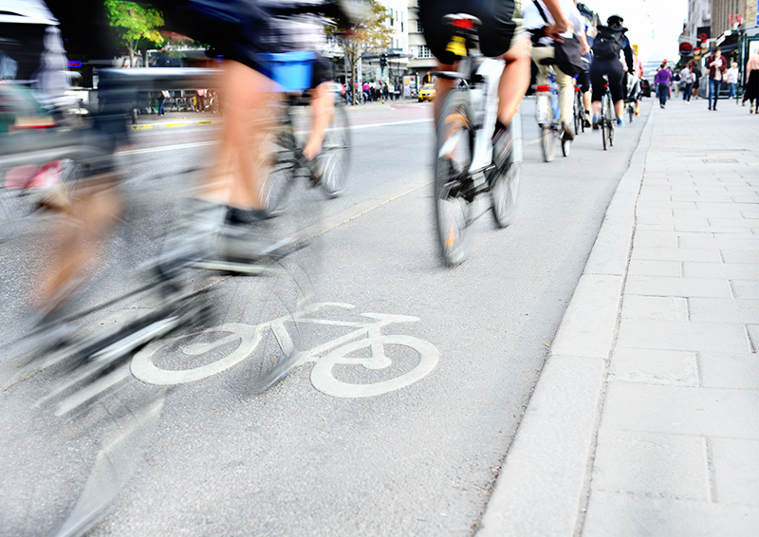

The Highway Code is being updated to better focus on cyclists

* **Updated:** 14 October, 2020
* **Author:** [Mark Hansford](mailto:knowledge@ice.org.uk), ICE Director of Engineering Knowledge

That the UK infrastructure sector’s rate of carbon reduction is falling short of the government’s net-zero target rate is perhaps not a major shock. But it was nonetheless a clear call to action for the civil engineering profession as the findings were revealed at this month’s [Unwin Lecture](https://www.ice.org.uk/news-and-insight/latest-ice-news/carbon-reduction-falling-short-of-net-zero-target" \t "_self).  
  
In a first update of infrastructure carbon data since the Government’s Infrastructure Carbon Review of 2013, ICE’s research has shown that the rate of reduction needs to grow from the current speed of 3% to 4.1% per year.  
  
This is despite a 23% reduction in total infrastructure carbon between 2010 and 2018 and a 44% reduction of carbon under ‘control’ of the infrastructure industry between 2010 and 2018. 

**Are we consistent with the net-zero vision?**

As ICE Carbon Project member and research fellow in industrial climate policy at the School of Earth & Environment, University of Leeds, Jannik Giesekam put it:  "Every engineer needs to ask themselves if the project they are working on now is consistent with that net-zero vision.  
  
“We now need even faster transformations in transport, water and communications. With rising capital carbon emissions and increased stimulus spending on the horizon, our focus must be on ‘building back better’ not just ‘build, build, build’.”   
  
 Incoming ICE President Rachel Skinner will send out exactly this message and stress the need for urgent action in her [inaugural address](https://www.ice.org.uk/news-and-insight/latest-ice-news/rachel-skinner-net-zero-warning-inaugural-address) on 3 November. But she will also stress the scale, and excitement, of the opportunity.  
  
Civil engineers are in a privileged, almost uniquely privileged, position of being at the heart of the drive to net-zero; whether it is accelerating the transition to renewable energy sources through design and construction of mega offshore wind arrays – as backed by prime minister Boris Johnson this month – or delivering smaller scale local interventions that get people out of petrol-powered cars and off diesel-fuelled buses and walking and cycling instead.  
  
This crucial part of the agenda was the subject of another ICE event this month, spearheaded by multi-medal winning Paralympian and Sheffield City Region active travel commissioner Dame Sarah Storey.

**Watch the debate on Active Travel again below.**

[*Active Transport Strategy Session Sept 22nd*](https://vimeo.com/460612431)*from*[*ICE Group*](https://vimeo.com/icegroup)*on [Vimeo](https://vimeo.com/).*  
  
Storey's stats were simple and striking. In her region 40% of journeys of 1km or less are made by motor vehicle, rising to over 60% for journeys of 5km. That cannot be beyond the skills of civil engineers to change that.

**A rethink on how civil engineers approach highways design**

It starts with having the right mindset. As Storey said: “Right now we only create cycling infrastructure for commuting. We should be building infrastructure for everyone to use, so that people can cycle to pick up their children from school or to go for a coffee with friends.”  
  
And it is not as if there isn't support. The UK government has committed £2bn of new investment and promised “much higher standards” for planning and design. The prime minister is again at the front of the message. “People want the radical change we are committing to in this strategy, and we politicians shouldn't be afraid to give it to them,” he said in announcing the investment. In support of this agenda the Highway Code is being updated to better focus on cyclists, a move which ICE supports. There is a massive open-door agenda for a complete rethinking of the way civil engineers approach highways design.  
  
Key to embracing this will, as ever, be strong [community engagement](https://www.ice.org.uk/events/ice-strategy-value-of-community-engagement). So that is the knowledge focus this month, as we deliver a strategy session squarely aimed at demonstrating good practice principles and providing specific examples of where infrastructure professionals have worked with the public on infrastructure projects to achieve the optimum solution for the community.  
  
Do sign up and hear from a spectacular, diverse and expert panel of experts headed by ICE vice president Anusha Shah and hear how civil engineers can work with communities to build and maintain infrastructure assets which actually benefit and improve their lives.

Be sure to join incoming ICE President Rachel Skinner's inaugural address on 3 November where she will be discussing the importance of carbon emission reduction and the need for urgent actions. [Book the event here](https://www.ice.org.uk/events/presidential-address-2020).